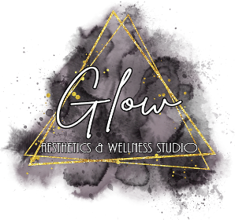
Universal Precautions Policy & Procedures
PURPOSE:
To ensure that all team members use Universal Precautions when providing patient care or performing any modalities with patients.

RESPONSIBILITY/COMPETENCY:
It is the responsibility of all Glow Aesthetics and Wellness Studio, LLC employees, owners, injectors, contractors, & assistants to be knowledgeable of this policy and include it in their patient care.

POLICY:
Universal Precautions are to be used when treating any patient or performing any modalities with patients. These guidelines are used to protect patients and personnel from the potential spread of infections.

PROCEDURE:
1. Gloves are to be worn any time contact with body fluids or mucus membranes is possible.
2. Protective eye wear and gown should be worn if there is potential for splashing or splattering of body fluids.
3. If contact of any body fluid occurs on clothing or skin. Clothing should be changed prior to returning to work. Skin is to be washed with an appropriate germicidal cleaner.
4. Any open wound on one’s hands requires gloves be worn.
5. All soiled linens are placed in the assigned laundry bags.
6. All moist and/or bloodborne contaminant trash is to be placed in red bags.
7. All general trash is placed in brown trash bags.

